Unlocking India’s AI Potential
Evaluation of IndiaAI Mission’s Common Compute Facility

Second-Year Policy Analysis (SYPA) - Draft

Prepared by: Prateek Pillai & Surbhi Bharadwaj
Section Leader: Anders Jensen
Advisor: Dani Rodrik
Client: IndiaAI Mission, Ministry of Electronics and Information Technology

February 1st, 2026

Written in fulfilment of the requirements for the degree of Master in Public Administration in International Development, John F. Kennedy School of Government, Harvard University.
© 2026 Prateek Pillai & Surbhi Bharadwaj. All rights reserved, except as granted to the President and Fellows of Harvard College in the SYPA Non-Exclusive License.
Acknowledgements 3
Executive Summary 4
Introduction 5
Client context and objective 7
CCF structure and subsidy 9
Target CCF end user 13
Key facts about current allocations 14
Methodology 16
Literature Review 18
Country Case Studies 18
Industrial Policy 20
Problem specification & diagnosis 23
1.1 Low perceived returns to AI innovation 25
1.2 Administrative frictions in accessing common compute 26
2.1 Human Capital 27
3.1 Financial 28
3.2 Infrastructure mismatch 28
Policy recommendations 29
1.1 Low perceived returns to AI innovation 29
1.1.1 Advance government procurement commitments in priority domains 29
1.1.2 Milestone-based compute allocation with “Go / No-Go” gates 29
1.2 Administrative frictions in accessing common compute 30
1.2.1 Time-bound GPU provisioning guarantees 30
1.2.2 Voucher model instead of approval pathways 30
2.1 Human capital 31
2.1.1 Leverage compute access as a tool for talent development and ecosystem formation 31
Evaluation of policy recommendations 31
Evaluation criteria 31
Final Recommendation and Implementation Plan 32
Conclusion 33
Appendix 33

Acknowledgements
To come

Executive Summary
The Government of India has articulated ambitious goals to become a global leader in Artificial Intelligence (AI). In furtherance of these goals, the IndiaAI Mission launched the Common Compute Facility (CCF) in 2025 to expand access to advanced GPUs for domestic startups, researchers, and public institutions, by empanelling private data-center providers and offering subsidized rates. Despite empanelling over 34,000 GPUs by late 2025, less than half of this capacity has been utilized. This SYPA evaluates why uptake has lagged and how the IndiaAI Mission can increase utilization in service of its broader goal of catalyzing AI innovation in India.
Using a mixed-methods approach combining stakeholder interviews and administrative data, we diagnose the constraints limiting CCF usage. We find low perceived returns to AI innovation and administrative frictions in accessing compute to be major binding constraints, with poor access to high-quality human capital emerging as an ancillary constraint.
To address these constraints and increase CCF utilization, we recommend two policy reforms. First, the Government of India should commit to advance government procurement of AI solutions in a limited set of high-priority public sector domains. Second, the IndiaAI Mission should establish clear GPU provisioning guarantees to ensure that GPU allocations are executed in a time-bound way. Together, these measures would reduce uncertainty around the benefits of AI innovation, position the CCF as a credible provisioner of compute, and help catalyze AI innovation in India.

Introduction
In February 2026, India played host to a global AI summit that brought together <to fill in the blanks after summit>. India’s AI ambitions are now well-known. As early as 2020, Prime Minister Narendra Modi was proclaiming ambitions to make India a “global hub for AI.” Today, India is the second largest, and most rapidly growing, market for major AI platforms such as OpenAI’s ChatGPT and Anthropic’s Claude.
IndiaAI Mission’s Common Compute Facility (CCF) was set up in 2025 to reduce the effective price of GPU compute for domestic end users by empaneling private data-center providers and providing subsidies to users. By November 2025, CCF had empaneled over 34,000 GPUs but had allocated less than 50% of its monthly capacity (Figure 1). This utilization gap is puzzling: compute demand has skyrocketed around the world and CCF demonstrably reduces the cost of compute for end users. Why then, are end users not using the facility?
The central policy puzzle we evaluate is: How can IndiaAI increase utilization of CCF in support of the broader objective of stimulating India’s AI innovation ecosystem?

Figure 1: CCF allocations use up less than 50% of available GPU capacity
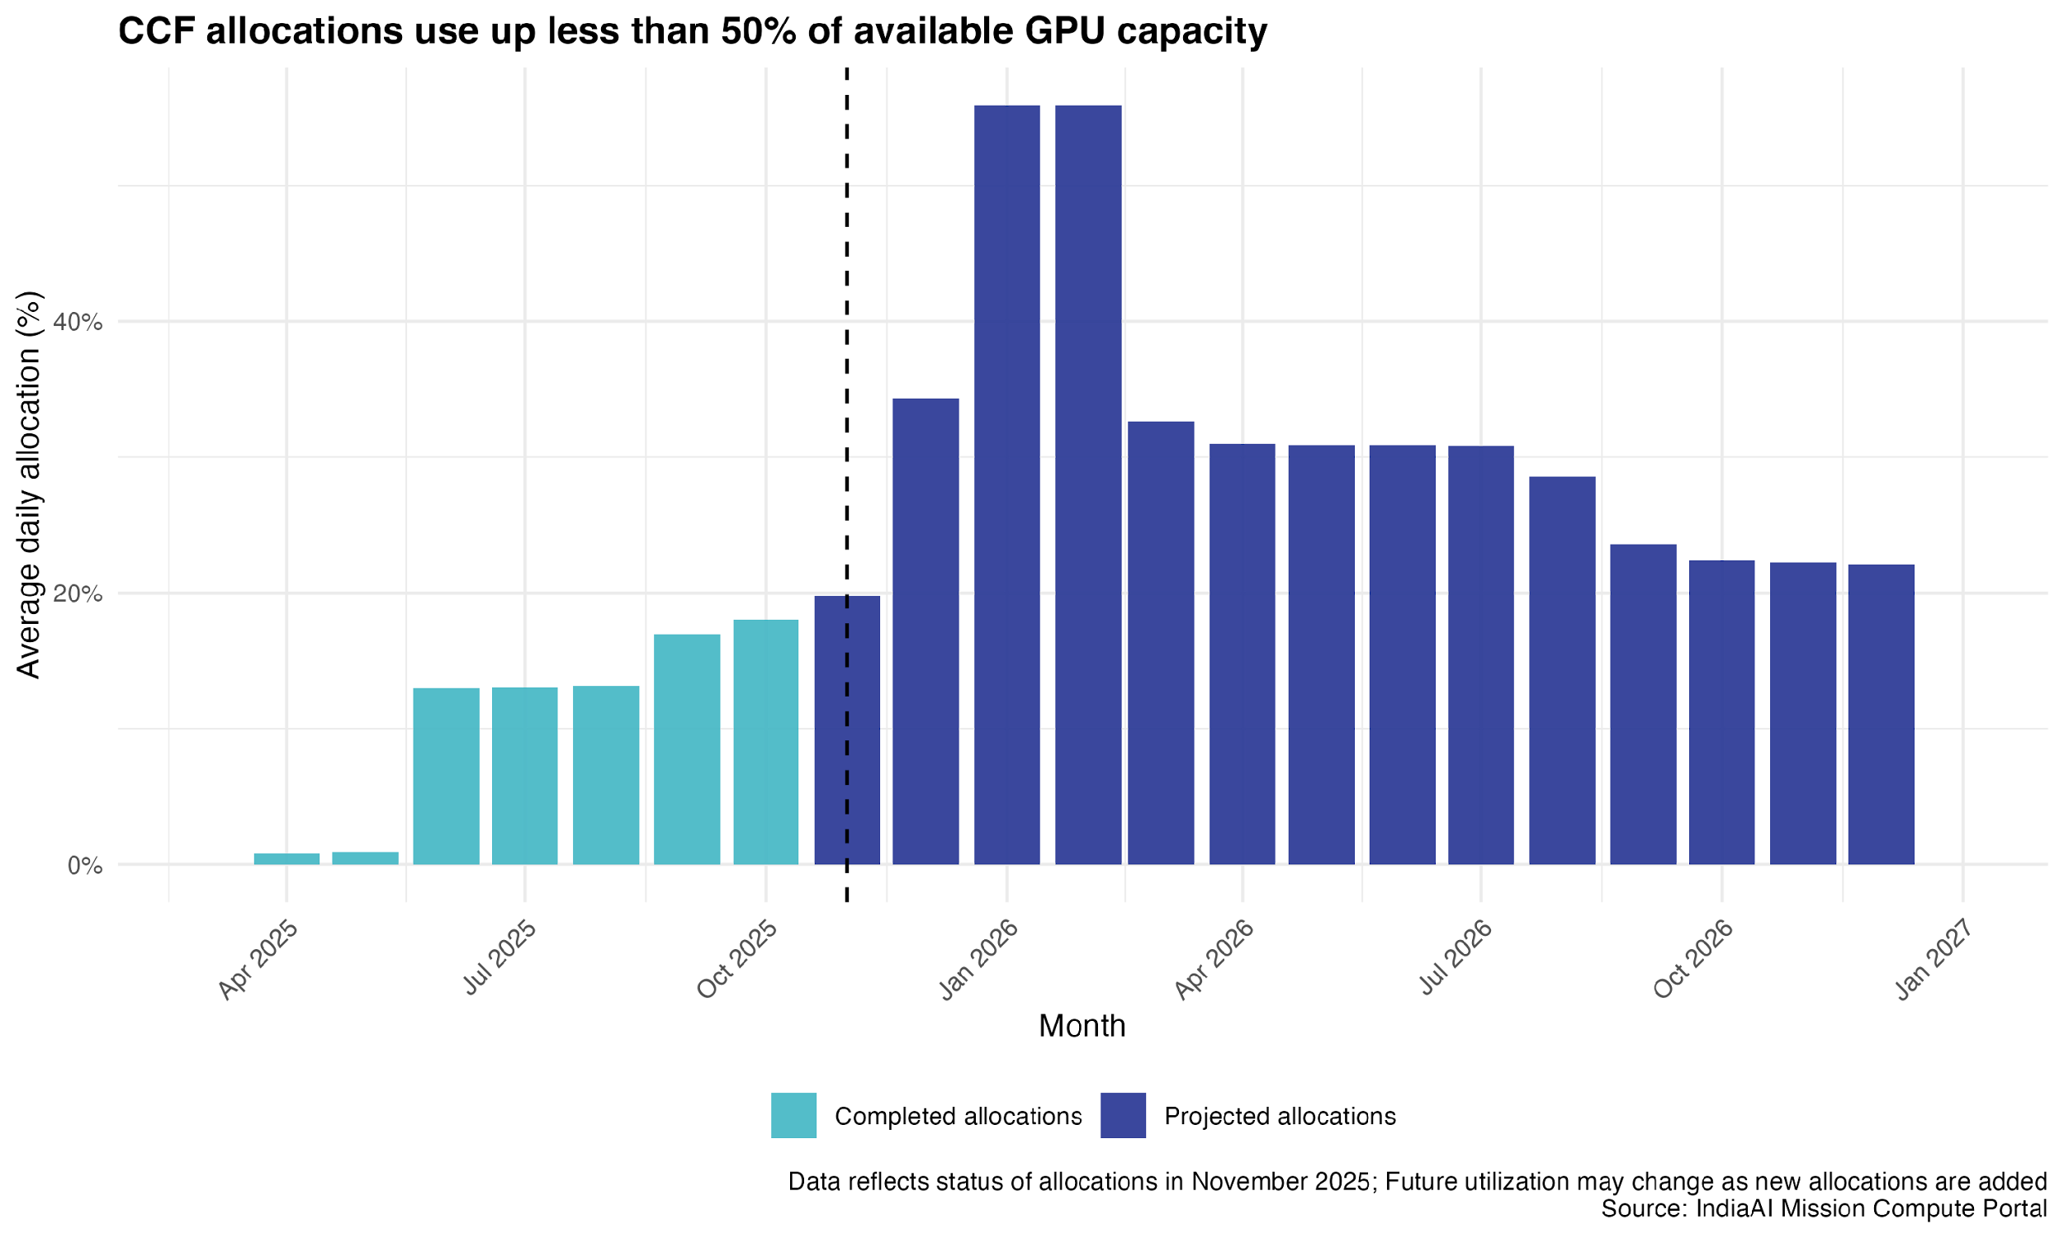
We are motivated to study this problem for several reasons:
- Inflection point for India’s tech leadership: India is well-positioned to become a leader in AI with a large base of technical talent, demonstrated connections to global tech firms, and a vibrant startup ecosystem. However, AI innovation is far more capital intensive than the software innovation India has excelled at thus far. Specifically, compute capacity is emerging as a bottleneck. India is home to 5 compute regions, compared to 22 in China and 26 in the US. Absent significant capacity for training and inference, Indian actors face an uneven playing field for AI innovation. Competition has become more capital intensive and India's labor advantage does not hold. In such a world, one would assume demand for compute because the premium is not on labor. Indian firms will face lower capacities and higher costs in accessing compute, eroding the country’s historic competitive advantage in low-cost tech innovation.
- Sovereign AI considerations: AI is increasingly becoming a front for geopolitical power. AI, especially large language models (LLM) are general purpose technologies, but they are not strictly agnostic of their origin and context. LLMs embed cultural values of the data they are trained on. Advanced AI is also expected to lead to military dominance for the winners, further muddying the line between technological advancement and geopolitical interests. Chinese and US companies currently operate 90% of public cloud AI facilities globally. In this context, India is pursuing a sovereign AI strategy founded on creating a public-sector led, open innovation ecosystem – including indigenous language models, government applications etc. Accessible and affordable compute infrastructure is a key enabler of this.
- Distributional implications of access to AI infrastructure for end users: AI has significant distributional implications, both globally and within India. Access to affordable compute determines who gets to experiment, who can absorb early losses, and who captures future rents from AI-driven productivity gains. Without public intervention, well-capitalized organizations are face fewer barriers to entry. This may limit the scope of innovations pursued – as smaller startups, researchers, and academics are shut out of compute access. CCF aims to expand such access, but if it ultimately underutilized, the status quo that biases towards concentration will persist.

Client context and objective
AI is increasingly a general-purpose technology that has implications for industrial competitiveness, public service delivery, and national security. Governments across the world are therefore grappling with the central policy question: how to leverage AI to meet economic and societal goals.
The IndiaAI Mission – a national program housed under the Ministry of Electronics and Information Technology (MeitY) – was set up in March 2024 to help answer this question.
The Mission has been allocated INR 10,371 crore (USD 1.25 billion) over five years and its central objective is to catalyze AI innovation in India and drive its responsible, inclusive growth. This means giving Indian firms, researchers, and public institutions the tools they need to build AI systems that serve the country’s economic, social, and linguistic realities.
IndiaAI Mission consists of seven pillars spanning the AI supply chain: data, compute, skilling, and applications (Figure X). The Common Compute Facility (CCF) aims to increase the availability of GPUs at affordable rates to a range of actors, including startups, researchers, and non-profits. Common Compute is the Mission’s largest pillar, accounting for INR 4,568 crores (USD $550 million) or 44% of the total allocation. Compute fits into the Mission’s goals by enabling domestic actors to train their own models and build AI products without being hamstrung by the high cost of commercial cloud compute.

Figure 2: Seven Pillars of India AI Mission
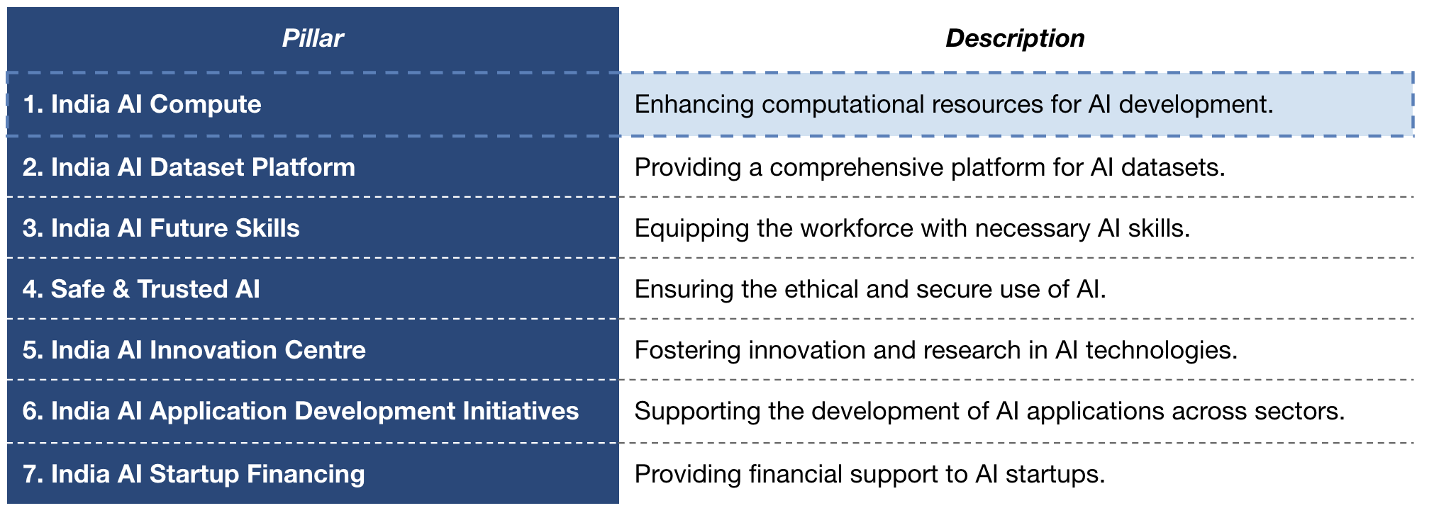
While the CCF claims to have acquired over 34,000 GPUs since its launch, its utilization remains low. Further, even with the rapidly expanding scale of domestic compute, India lags far behind global leaders. For instance, Microsoft alone purchased 500,000 advanced GPUs just in 2024. The IndiaAI Mission enlisted our support to understand the factors contributing to this poor uptake and propose improvements to meet the Mission’s overarching goals to bolster the AI ecosystem in India.

CCF structure and subsidy
In 2024, the Government of India (GoI) has committed to spending over $500 million over the next five years towards building the CCF. To build the stack, instead of buying graphics processing units (GPUs) outright, the Mission empanels private data center operators through a competitive bidding process. These GPUs are then allocated to end users at a subsidized rate (up to 40% of the bid price). Domestic firms, researchers, and public institutions are thus able to access GPUs at rates well below market levels.
The CCF operates in two distinct stages: (i) procurement of compute capacity, and (ii) allocation of compute to end users (Figure 3).

Figure 3: Flow of compute and funds orchestrated by the IndiaAI Mission
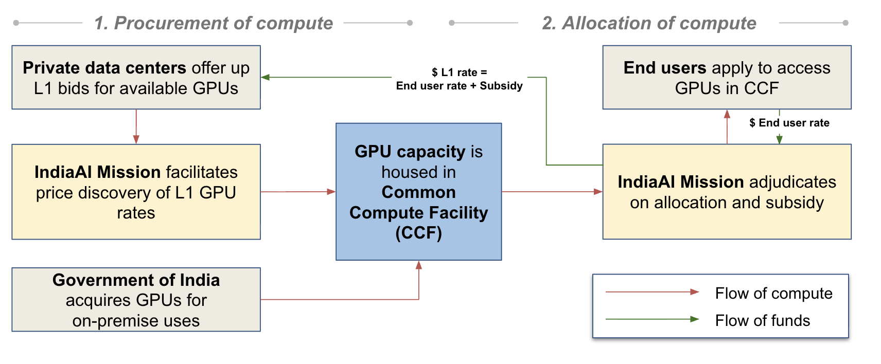
- Procurement of compute
To procure compute, IndiaAI conducts a competitive bidding process in which private data center operators submit bids to supply specific GPU types (e.g., A100, H100, L4) at specified per-unit rates. Bids are ranked to determine L1 rates, i.e. the lowest eligible price for a given GPU category.
Through the empanelment process, the government derisks capital investment as private operators commit their existing or planned chips to CCF at L1 rates. The hardware remains owned and operated by the private provider, and public funds are disbursed only when GPUs are actually used by approved end users.
This design allows the Mission to:
- Rapidly aggregate large volumes of compute without incurring capital expenditure risk
- Conduct price discovery in the market
- Prevent infrastructure lock-in as GPUs evolve rapidly while delivery times remain long
The incentives of private operators to join the CCF are more mixed. Since they don’t get paid until compute is allocated and utilized, the facility does not operate as a demand guarantee. Instead, interviews with empanelled providers suggest that participation is motivated primarily by long-term market-shaping considerations rather than short-term revenue. One private compute provider described the CCF as a way to “take a haircut on pricing today in order to shape the market tomorrow,” emphasizing that compressed margins at L1 rates are acceptable if the program succeeds in expanding the domestic AI ecosystem and creating future inference demand.
- Allocation of compute
End users, including domestic startups, academic researchers, and public institutions, apply to access GPUs through the IndiaAI portal. Applications specify the requested GPU type and quantity, duration, intended use case, and whether a subsidy is sought. The Program Monitoring and Evaluation Committee (PMEC) adjudicates these applications to allocate compute and subsidies. For most routine users, the subsidy covers up to 40 percent of the L1 bid price, reducing the effective price faced by end users well below prevailing market rates (Figure 6).

Figure 4: Process of GPU procurement, allocation, and end use
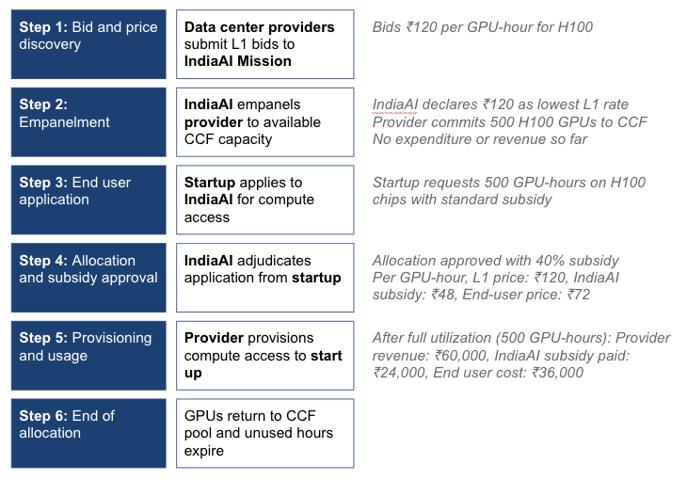
Some projects deemed strategically important are however being allocated significant compute at higher subsidies (Figure 9). In November 2025, 8 new companies were selected to train foundational models using Indian language, adding to 12 prior selections. These companies are being allocated significant compute via CCF, though the exact mechanism for adjudication remains unclear.

Figure 5: Compute approval and allocation workflow
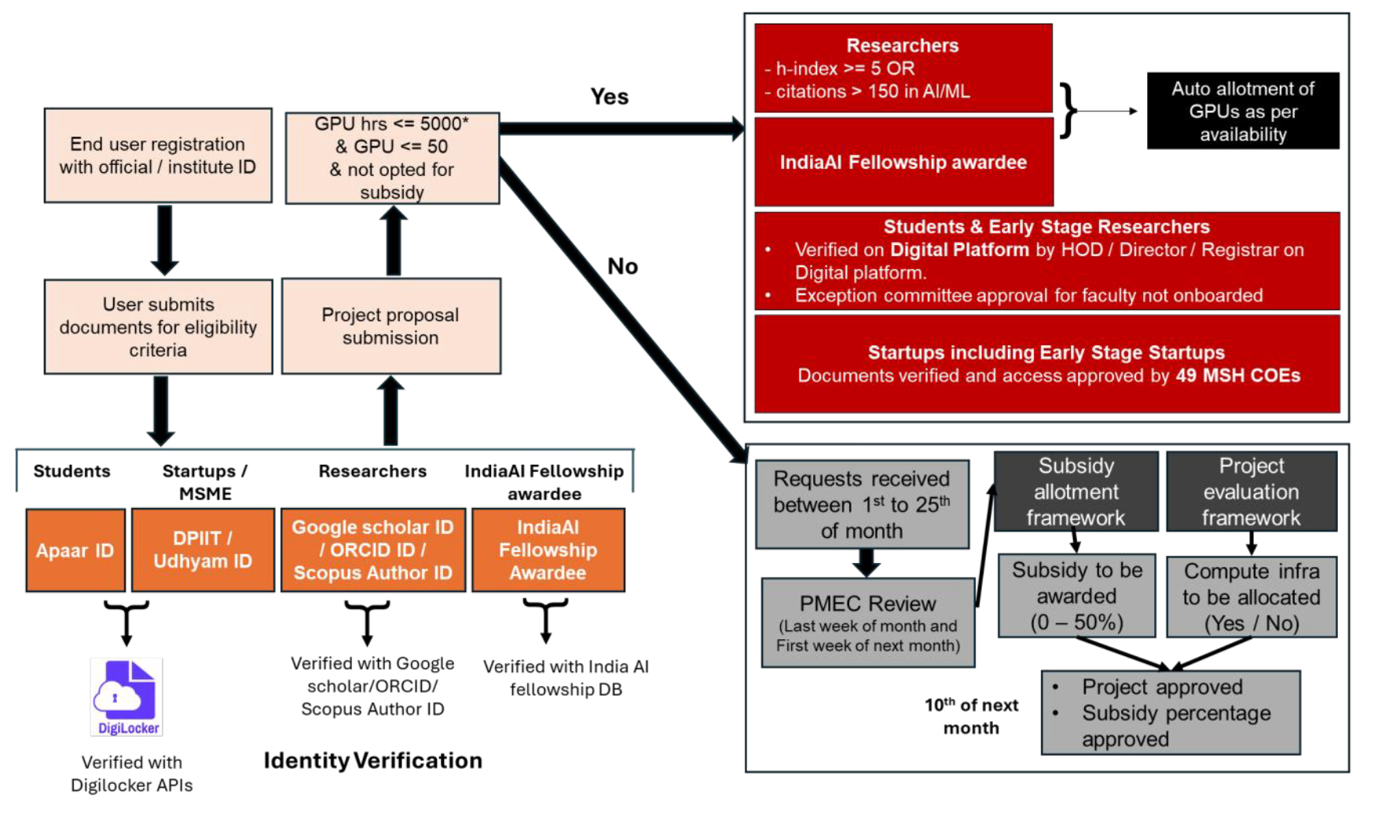

Figure 6: CCF substantially reduces end user costs beyond market rates
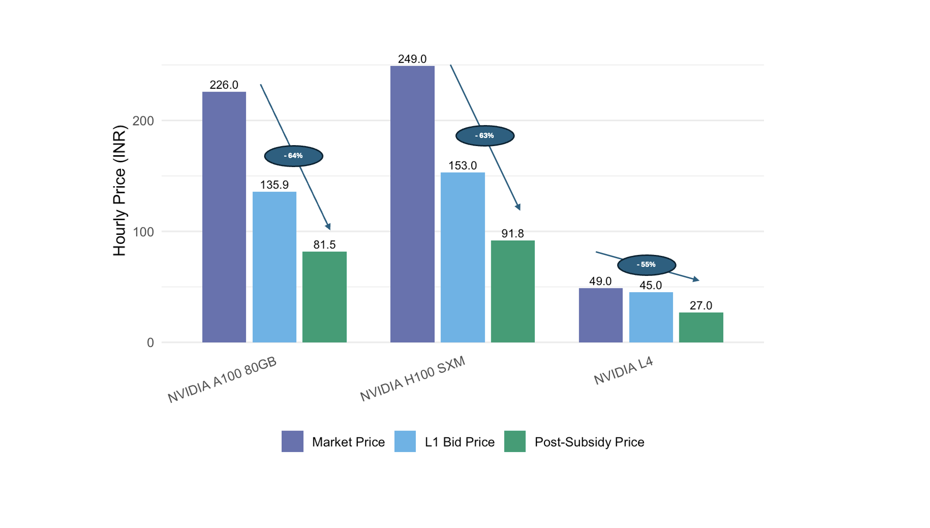

Target CCF end user
The target end users of the CCF are domestic actors who face binding cost and access constraints to advanced GPUs, and whose AI work is expected to generate national-level economic, social, or strategic value. For the approval process, IndiaAI Mission divides them into four categories: Researchers

Figure 7: End user groups eligible for CCF access
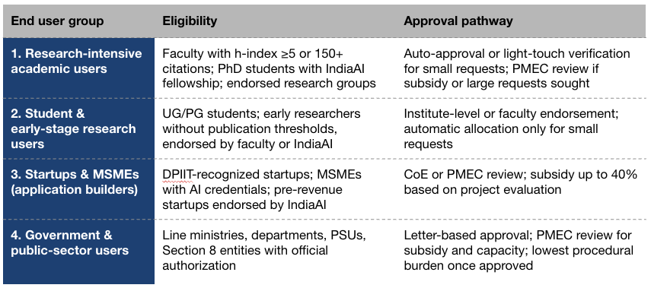
CCF is designed to serve AI users that require access to dedicated compute capacity. This is in contrast to firms using existing models through API-based services, such as OpenAI’s GPT and Anthropic’s Claude. Firms that require their own compute access are thus likely to be foundation model developers, startups using open-source models, government departments deploying AI applications on sensitive or large datasets. In contrast, users whose AI needs are met through closed models or lightweight inference tasks are not the intended beneficiaries of subsidized GPU infrastructure.
This distinction is critical to how CCF supports India’s sovereign AI goals. Another version of the program could have simply provided vouchers to subsidize access to API-based closed models, which would’ve also helped firms contributing to the AI innovation ecosystem. However, such a program would not have built durable domestic capabilities and incentivized more fundamental AI innovation, beyond simply fine tuning or inference on existing (largely foreign owned) models. By contrast, direct access to GPU compute enables upstream and intermediate forms of AI innovation that are critical for long-term technological capability. Owning or controlling compute resources gives developers greater freedom to experiment with model architectures and adapt models for constraints unique to the Indian context.
The CCF is thus not designed to maximize the number of AI users, but to catalyze a smaller set of compute-dependent actors whose activities generate spillovers in the form of domestic models, applications, and public-sector deployment. The effectiveness of the CCF should be evaluated on whether these activities would have emerged absent targeted intervention.

Key facts about current allocations

Figure 8: Government entities are the largest user category
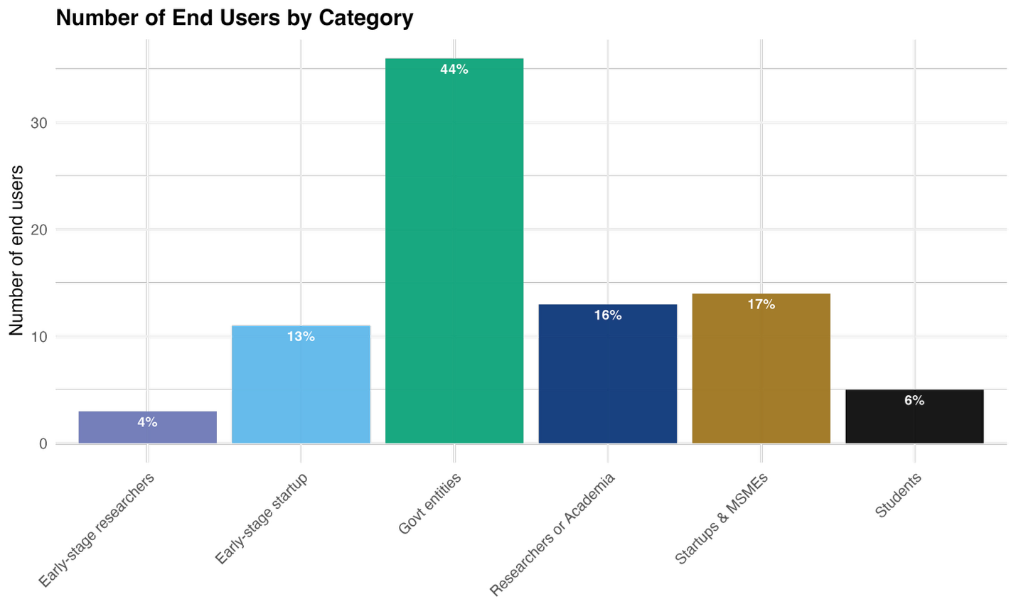

Figure 9: A small number of organisations, mostly startups and researchers, account for bulk of subsidies provided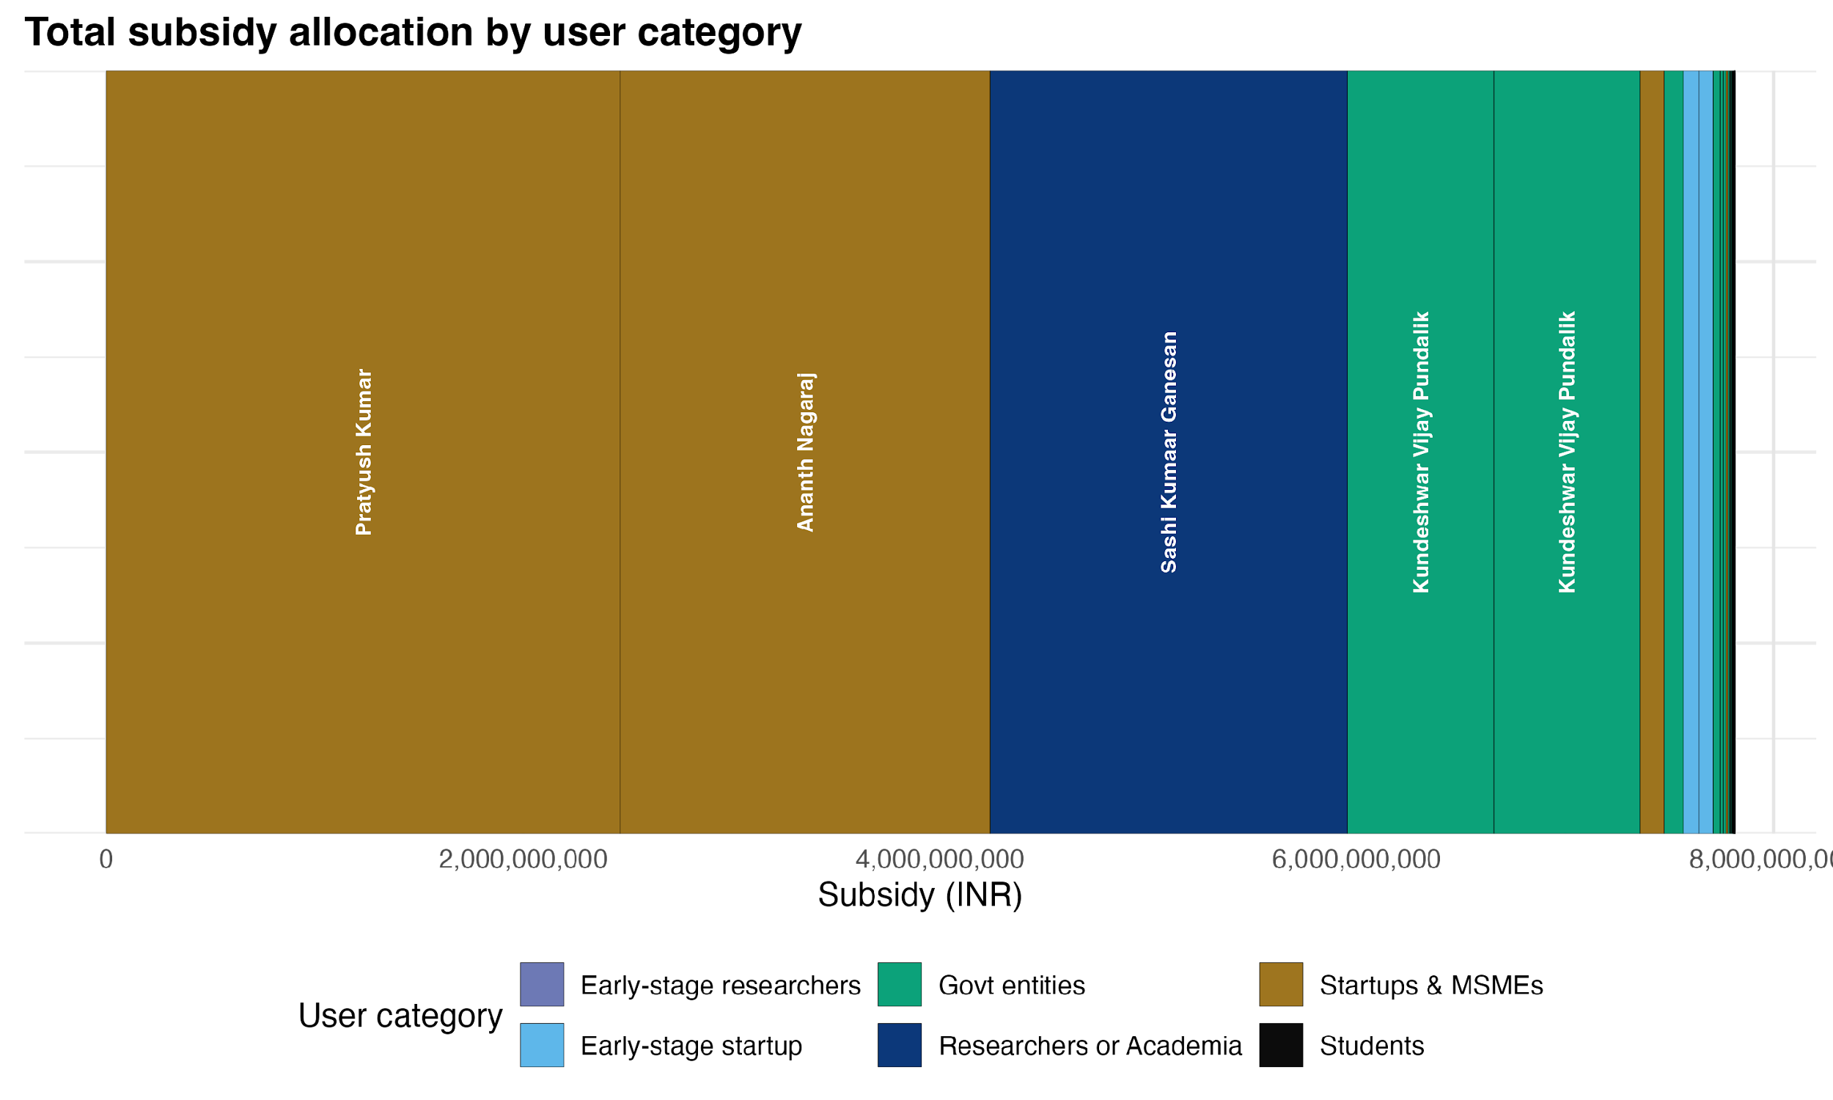

Figure 10: Larger GPUs allocations receive greater percentage of subsidies
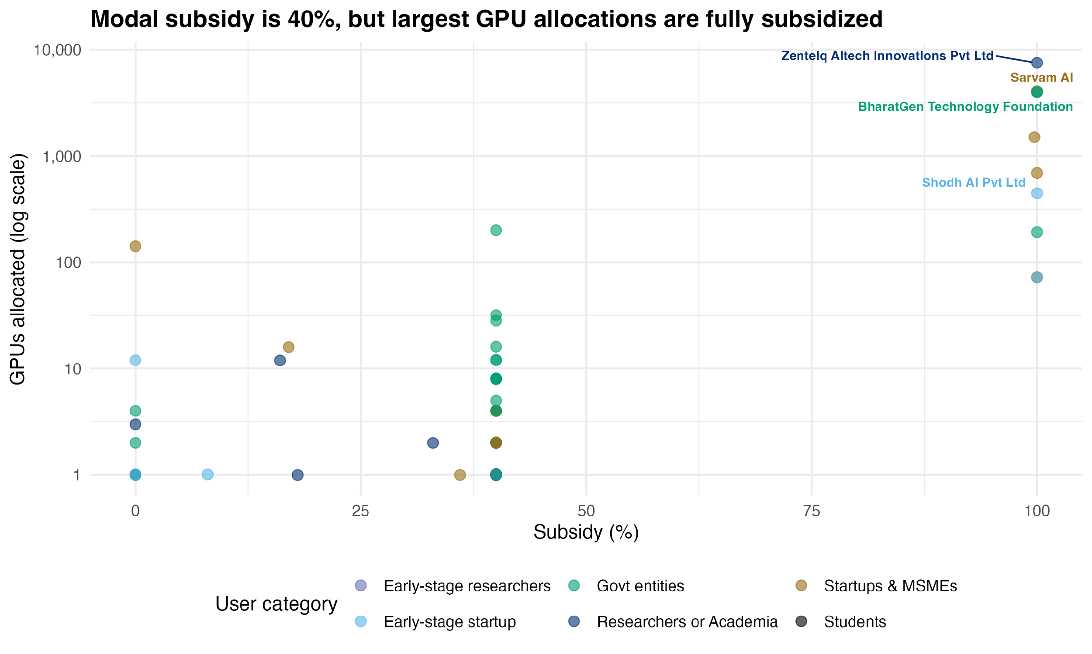

Methodology
This study adopts a mixed-methods approach combining primary qualitative research with secondary policy analysis. Given the novelty of the policy intervention and the limited availability of historical or administrative data, the analysis places particular emphasis on primary stakeholder interviews, complemented by descriptive administrative data and comparative evidence from global industrial policy experiences.

Figure 11: Key stakeholder archetypes and interviews conducted
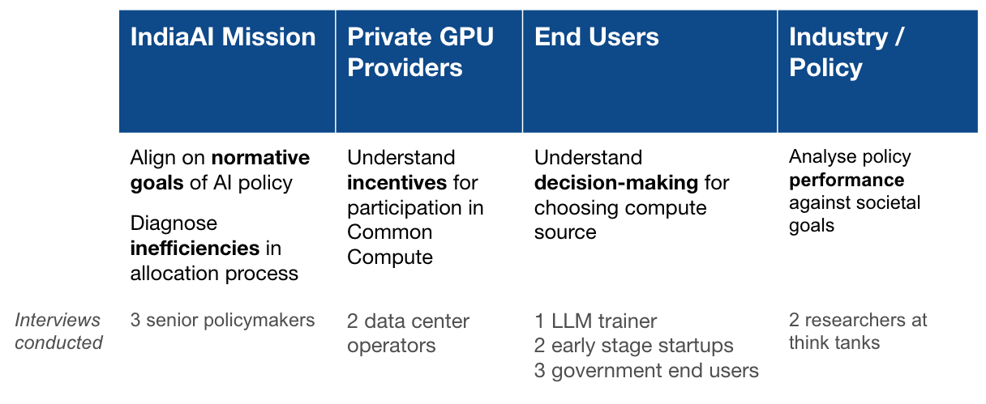
1. Primary research
CCF was only established in 2024, and the provision of “common compute” as a public or quasi-public good remains a relatively novel policy instrument globally. As a result, there is limited ex ante evidence on expected utilization patterns, incentive responses, or implementation challenges. To evaluate the effectiveness of the IndiaAI program in this context, we relied heavily on primary qualitative research with key ecosystem stakeholders.
We conducted semi-structured interviews across four stakeholder groups: (i) senior policymakers and implementers within the IndiaAI Mission and MeitY to clarify the normative goals of AI policy and diagnose administrative and design frictions; (ii) private GPU and data-center providers empanelled under the CCF to understand incentives for participation and constraints on supply; (iii) end users of compute to assess decision-making around compute sourcing and practical barriers to uptake; and (iv) industry and policy researchers to evaluate program performance against broader societal and industrial policy objectives.
Interviews were semi-structured and focused on a common set of themes tailored to each group, including perceived returns to AI innovation, cost and non-cost barriers to accessing compute, administrative frictions in the allocation process, and expectations about the role of public compute in India’s AI ecosystem. This approach allowed us to triangulate perspectives across actors who interact with the CCF from different positions in the value chain.
In addition to interviews, we obtained administrative data from the IndiaAI Mission on empanelled bid prices and end-user GPU allocations through November 2025. These data allowed us to document price discovery outcomes and compare allocated capacity to total empanelled capacity.
However, detailed data on capacity utilization and the specific GPU commitments from private providers was not shared with us. This would’ve helped us calculate how many GPU hours are actually consumed by end users upon allocation and the composition of GPU commitments by different providers. Instead, we relied on allocation data to point to underutilization of total available capacity.
2. Secondary research
We complemented our primary research with a review of secondary literature on industrial policy and public provision of general-purpose infrastructure, as summarized in the literature review. Given the scarcity of empirical work specific to AI compute, we focused on two adjacent bodies of literature:
- Country case studies of public or publicly supported compute infrastructure in China, US, and EU. These cases provide comparative insight into alternative institutional designs for supplying compute.
- Industrial policy literature on general-purpose technologies to understand how scale, complementary investments, and adoption frictions shape realized returns. This literature informs our diagnostic framework by identifying potential constraints and narrowing down to binding ones.
3. Methodological and data limitations
This analysis has several limitations. First, it relies on stakeholder interviews, which may reflect partial information or strategic perspectives. We sought to mitigate this risk by interviewing actors across four different use archetypes as highlighted above (Figure 11).
Second, the absence of granular utilization data limits our ability to assess heterogeneity in usage across GPU types, user categories, or project types. Access to such data would have enabled more prescriptive recommendations regarding which classes of end users to prioritize, which compute configurations are most prone to underutilization, and where the Mission faces the greatest blind spots.
Finally, because the CCF is still in an early phase of implementation, our findings should be interpreted as diagnostic, with recommendations aimed at improving program design as it scales rather than evaluating long-run impacts.

Literature Review
Given the rapidly changing state of AI technology and the relatively novel policy space it has created, empirically rigorous literature on the topic of compute access is relatively sparse. Instead, we adopt a two-pronged strategy: examining case studies of policy responses on common compute around the world and drawing lessons from historical industrial policy responses to other general-purpose technologies.

Country Case Studies
Countries around the world have adopted a range of strategies to expand compute access, ranging from an entirely market-led approach in the US to state-led in China. Compute distribution follows a power law – the US and China account for a majority of the world’s compute, only 32 countries have data centers at all, and over 150 countries have no indigenous compute access.

Figure 12: Spectrum of common compute approaches across key economies
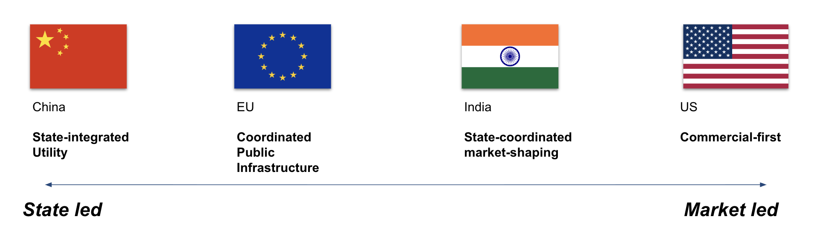
China has pursued a state-led model for public compute spanning central, state, and municipal governments. The National Integrated Computing Power Network (NICPN) is creating an “integrated grid of AI computing centers, data center clusters, and supercomputers spearheaded by Huawei.” The “Eastern Data, Western Computing” initiative builds large server farms in inland provinces with cheap land and power. Then, local governments run compute voucher programs (covering 40–50% of cloud costs) to help startups and researchers access these state-run data centers. Together, these initiatives are seeking to make compute akin to a “public utility, like waterways and electricity.” However, some observers speculate that China may be sitting on tremendous excess capacity, with nearly 80% of this compute lying unused.
United States has relied more on public-private partnerships and targeted programs. While major cloud compute is provided by firms like AWS, the US government is seeding initiatives like the National AI Research Resource (NAIRR) to provide academic researchers with cloud compute credits and data in a streamlined way. Agencies (NSF, DoE) also fund large supercomputers (e.g. for open science) and mission-driven AI testbeds. However, downstream usage of compute is left to private and commercial forces. For instance, Anthropic and OpenAI are running their own programs to provide subsidized access to compute for researchers.
European Union runs a centralized, open-science model to access compute through EuroHPC, a joint undertaking that pools funding to operate a network of shared, supercomputers. Access to industry players and startups is contingent on open publication of their work. EuroHPC has a budget of approximately 7 billion euros from 2021 through 2027.
Public compute infrastructure in other countries severely lags, illustrative of the “global compute divide.” Brazil and South Africa have some clusters for high performance computing, and Indonesia has recently announced a national AI strategy. However, these initiatives remain far from the scale at which the leading countries are operating.

Industrial Policy
AI shares key characteristics with earlier general-purpose technologies such as electricity and the internet, particularly in terms of its potential impact on the economy. As with these technologies, the magnitude of AI’s contribution to growth and productivity will depend not only on technological advances, but on the policy and institutional frameworks that shape its diffusion and use. Examining how industrial policy has succeeded or fallen short in past episodes involving general-purpose technologies therefore provides useful guidance for the design and implementation of CCF. Literature on these past instances of industrial policy yield three major takeaways:
Takeaway #1: General-purpose technologies delivers returns only in the presence of complementary assets
Implication: CCF will be effective in supporting AI innovation, only if adjacent constraints on human capital, downstream demand, etc. are resolved
General-purpose technologies generate economic returns only when paired with complementary assets. The technology itself is rarely sufficient to induce productivity gains; instead, its impact depends on coordination with skills, firms, finance, and downstream demand. Evidence from rural electrification illustrates this dynamic: electrification has large positive effects on employment and industrial activity only when paired with complementary assets. Burlig and Preonas (2024) demonstrate that in many Indian villages, electrification failed to generate significant economic benefits if complementary assets—such as appliances, credit, and productive enterprises—were missing. When complementary inputs are absent, economies can become stuck in a low-adoption equilibrium.
Interviews with AI technologists and policy experts indicate that, much like electricity, AI compute functions like a general-purpose input whose adoption depends on the presence of complementary assets such as human capital and access to finance, that enable firms and institutions to translate access into innovation.
Takeaway #2: Reducing access barriers is critical for digital infrastructure investments to deliver returns
Implication: CCF will be effective only if end users are able to access the compute with low administrative frictions and transaction costs
Economic returns to digital infrastructure hinge on lowering barriers to adoption, particularly for smaller firms and households. Evidence from OECD countries shows that broadband investments are associated with higher GDP growth and employment, but only where prices are affordable and users possess sufficient digital literacy. Where access costs remained high or skills were lacking, broadband infrastructure was systematically underutilized, muting its growth effects.
Similarly, in the context of CCF, expanding compute supply may lead to limited benefits if other factors such as administrative frictions and transaction costs continue to pose as access barriers to greater utilization.
Takeaway #3: Targeted and transparent subsidies can crowd in private investment and accelerate strategic sectors
Implication: CCF will be effective only if end users are able to access the compute with low administrative frictions and transaction costs
Goldberg et al. (2024) find that in the context of semiconductors, targeted, transparent, and time-bound subsidies generated substantial spillovers by reducing early-stage risk and coordinating private actors around shared expectations. Conversely, fragmented or poorly governed subsidy regimes have tended to produce rent-seeking and limited technological upgrading.
AI compute exhibits many of the characteristics that justify such intervention. Compute is capital-intensive, subject to scale economies, and generates positive externalities through downstream innovation. Left entirely to market forces, investment may concentrate in a small number of large firms and global cloud providers, limiting diffusion and domestic capability development.

Problem specification & diagnosis
To diagnose the drivers of low utilization of the CCF, we employ a fishbone decomposition that systematically decomposes potential causes of underutilization across demand- and supply-side factors. This approach allows us to move beyond descriptive explanations and instead identify which constraints are most likely to be binding—that is, which factors, if relaxed, would lead to a material increase in uptake of CCF.
Following the logic of constraint-based diagnostics, we assess each factor based on three criteria: (i) whether it plausibly explains the observed utilization patterns, (ii) whether stakeholders consistently identify it as a limiting factor in decision-making, and (iii) whether variation in this factor is correlated with differences in adoption across users. This analysis enables us to distinguish between binding constraints, ancillary constraints that amplify other frictions, and non-binding constraints that are unlikely to be driving the observed outcome.
Based on this assessment, we identify perceived returns to AI innovation and administrative frictions in access as binding constraints; human capital constraints as ancillary; and infrastructure mismatch and financial constraints as non-binding.

Figure 13: Decomposition of potential constraints leading to underutilization
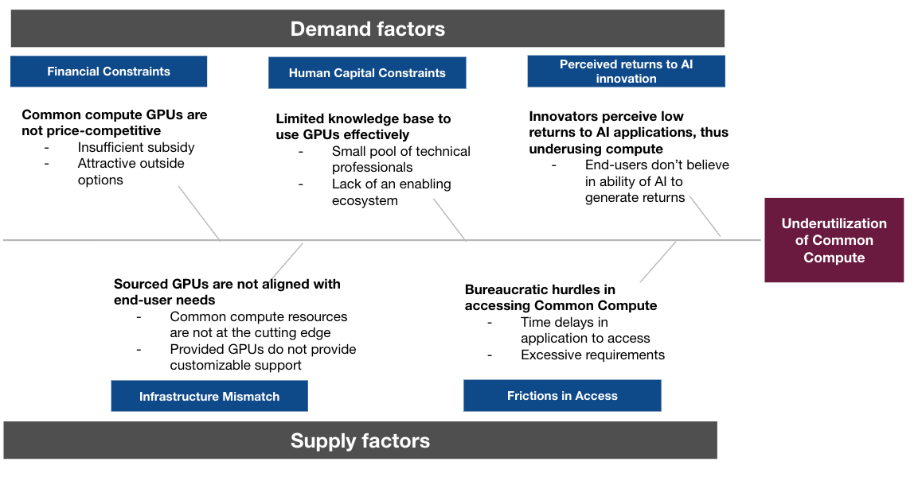

Figure 14: Evaluation of constraints to CCF
1. Binding constraints | 1.1 Low perceived returns to AI innovation | Despite heavily subsidized compute, many startups, MSMEs, and public institutions perceive the expected private returns to AI experimentation as too uncertain or distant—given weak demand signals, limited success stories, and high execution risk—to justify committing time, talent, and capital.
 | 1.2 Administrative frictions in accessing common compute | Delays and uncertainty between approval and actual GPU provisioning undermine the value of subsidized compute—especially for time-sensitive private actors—leading both approved users and prospective applicants to self-select out in favor of more predictable commercial alternatives.
2. Ancillary constraint | 2.1 Human Capital | Gaps in hands-on experience with training and deploying GPU-intensive models raise the perceived cost and risk of AI experimentation, amplifying the effects of low expected returns and access frictions rather than independently constraining utilization.
3. Non-binding constraints | 3.1 Financial | Given the magnitude of existing subsidies, compute prices are already well below market rates, and further cost reductions are unlikely to materially increase uptake relative to non-price barriers such as uncertainty, delays, and execution capacity.
 | 3.2 Infrastructure mismatch | At current utilization levels, concerns about GPU vintage, configuration, or customization are secondary, as available compute capacity exceeds effective demand and supply-side technical specifications are not the primary driver of underuse.

1.1 Low perceived returns to AI innovation
Our primary diagnostic finding is that demand for even heavily subsidized common compute remains constrained by low perceived private returns to AI innovation among the CCF’s target users. While the facility is priced competitively, many potential end users do not view investing in AI applications through dedicated compute as value generating. Interviews consistently revealed a bifurcation in the AI ecosystem: (A) a small set of actors who require their own compute—either for large-scale model training or inference on open-source models—and (B) a much larger set of organizations that engage with AI primarily through closed or externally hosted models accessed via APIs, without owning compute. The CCF is explicitly designed for Group A, yet uptake among this group remains limited. One data-center provider noted, “There are only two to six serious language-model players in the country… beyond that, adoption is still nascent and use cases need to be built,” while another emphasized that “people still think CCF is only for language models—you have to educate customers that they can approach it for their use cases.” These perceptions materially dampen demand for owned compute, even when subsidized.
Importantly, this low perceived return appears to reflect a wedge between actual and perceived returns, rather than an absence of underlying value. Evidence from comparable contexts suggests that AI adoption can generate significant productivity and revenue gains for firms and public institutions similar to CCF end users <cite studies on AI-driven productivity, firm performance, or public-sector efficiency gains>. However, interviews suggest that potential users heavily discount these returns due to risk aversion, uncertainty, and prior negative experiences with frontier technologies. A startup operator said, “There’s a traumatic experience from blockchain—people are now very risk-averse,” while another noted that “models have to be world-class before anyone believes they’ll make money off inference.” Capital constraints and short planning horizons further exacerbate this dynamic, particularly for startups and government departments that struggle to justify upfront investment in compute without near-term proof of value. As a result, actors who would need dedicated compute to generate long-run spillovers underinvest relative to the social returns of AI innovation, directly limiting CCF uptake.
Framework for returns
- Returns = Profit increase / investment
- Firms make investment decision based on assessment of private returns
- Private returns are driven by
  - Decreasing costs -- AI productivity, augmentation
  - Increasing revenue -- innovating new products, accessing new markets
- Social returns -- not part of investment decision at firm-level, but societally useful and something that government wants to increase
  - Innovation ecosystem
  - Sovereignty
  - Distribution

1.2 Administrative frictions in accessing common compute
While end users interviewed noted the process of applying for compute and approval was largely friction-free, most private players had not yet received access to their approved allocations. Interviews indicate that even after receiving formal approval from the IndiaAI Mission, many end users wait extended periods before GPUs are allocated. “I had completely forgotten about the CCF approval we received some months ago till you reached out to me about it”, mentioned a startup founder when asked about his experience with the CCF approval process. He added that the delay had created uncertainty around timelines and project execution for his team. These delays are not evenly distributed across user categories: public-sector entities tend to receive compute relatively quickly, while private-sector users—especially startups—face substantially longer and more uncertain timelines.
These access frictions materially affect demand because they interact directly with the low perceived returns described above. For private-sector actors operating under tight capital constraints and short development cycles, the expected value of investing in AI innovation depends not only on price, but on certainty around timing and delivery. Unpredictable delays therefore make CCF ill-suited for private sector use cases that require flexibility and speed, even when headline prices are attractive.
More broadly, experiences of delayed delivery reinforce the perception that accessing compute through government-mediated channels is friction-heavy and unreliable. This perception depresses demand ex ante, as potential users self-select out of the system before applying, opting instead for commercial alternatives that offer greater certainty despite higher costs. As of November 2025, there were less than 200 users registered on the IndiaAI portal, which is the first step of initiating an application for compute. In this sense, administrative delays function as a binding constraint not only by slowing utilization among approved users, but by reducing the pool of prospective applicants altogether.

2.1 Human Capital
Human capital limitations, such as a limited pool of professionals with experience in training and deploying GPU-intensive models, constitute an ancillary constraint. While insufficient skills do not independently explain low utilization, they interact with binding constraints by increasing the perceived risk and cost of AI experimentation. Organizations lacking in-house expertise are less likely to pursue compute-intensive projects in the absence of strong confidence in returns or seamless access to infrastructure. Human capital constraints amplify the effects of low perceived returns and access frictions, rather than acting as a primary bottleneck. As utilization increases and successful use cases emerge, these constraints may become more salient over time.
India’s Finance Minister has publicly noted that the pace of AI adoption is outstripping the development of skilled professionals able to deploy and manage these technologies effectively. This talent gap reflects deeper structural weaknesses in the education-innovation pipeline. While India produces a large number of graduates in science and engineering disciplines, the higher-education ecosystem has historically underinvested in advanced research and development, particularly in domains at the frontier of AI. Public expenditure on R&D remains low as a share of GDP, constraining institutions’ ability to offer research-oriented training, sustain world-class laboratories, or provide students with sustained exposure to cutting-edge work. As a result, the system often falls short of equipping graduates with deep, practice-oriented AI skills at the scale required for high-impact compute usage and struggles to retain the specialized talent it does generate.

3.1 Financial
The price competitiveness of CCF does not emerge as a binding constraint. As shown in Figure 6, compute provided through CCF costs < 50% of market rates. However, interviews with business executives at firms that are potential end-users of CCF indicated that many are willing to pay a premium to go through private cloud providers instead. This points to the salience of non-price constraints and implies that further price reductions are unlikely to generate large increases in uptake.

3.2 Infrastructure mismatch
Concerns around infrastructure mismatch, such as the age of GPUs or lack of customization, do not appear to be binding at current utilization levels. The CCF already provides access to the entire gamut of most-commonly used GPUs, including cutting-edge ones such as NVIDIA H100s. Moreover, interviews with startup founders indicated that the GPUs provided through CCF were largely identical to those that they would have acquired from private third-party providers in the absence of the program.

Policy recommendations

1.1 Low perceived returns to AI innovation

1.1.1 Advance government procurement commitments in priority domains
To directly raise perceived private returns to AI innovation IndiaAI Mission can pre-commit to procuring AI solutions in a limited set of high-priority public-sector domains, such as OCR of legacy government records, multilingual citizen-facing interfaces, and forecasting applications for statistics, weather, or public service delivery. An advanced market commitment (AMC) would credibly signal downstream demand contingent on minimum performance standards, thereby reducing uncertainty around market access for compute-intensive innovators. Such AMCs have demonstrated success in public health -- a $1.5 billion commitment for pneumococcal vaccines led to the development of three vaccines for LMICS.
Interview evidence suggests that uncertainty around monetization—not compute cost per se—is a key deterrent: end users emphasized that adoption only follows once use cases are clearly validated. By anchoring demand through advance commitments, IndiaAI can convert speculative AI investment into a quasi-contracted opportunity, increasing the expected returns to owning compute for target users without directly subsidizing outcomes or crowding out private buyers.

1.1.2 Milestone-based compute allocation with “Go / No-Go” gates
A complementary approach is to restructure compute subsidies around milestone-based allocation, modeled on venture-style financing and adaptive public R&D programs. Instead of granting large blocks of subsidized compute upfront, IndiaAI would allocate compute in phases:
- Phase 1 for prototyping and proof-of-concept
- Phase 2 for scaling validated models or applications
- Phase 3 for production deployment.
This is already de facto happening, given the differing scale of allocations for end users, but a clear articulation of phases could help scaling organisations measure their progress and be incentivized to move towards deployment of products at scale. Thus, CCF allocations will not get stuck in prototypes, but move across the development cycle into real-world impact.

1.2 Administrative frictions in accessing common compute

1.2.1 Time-bound GPU provisioning guarantees
IndiaAI Mission should introduce clear, time-bound service guarantees for realized access to compute once an allocation has been approved. The Mission would commit to provisioning compute within a fixed and publicly stated window, with automatic escalation or fallback mechanisms if timelines are breached. Such guarantees directly address the credibility problem that currently depresses demand. Provisioning guarantees would reduce execution risk, allow firms to align compute access with development cycles, and raise the expected returns to AI experimentation.

1.2.2 Voucher model instead of approval pathways
A complementary reform would be to transition from centralized allocation of compute to a user-centric voucher model, in which approved users receive compute credits that can be redeemed directly with empaneled data-center providers. This approach would remove the government from the critical path between approval and delivery, reducing coordination failures and delays that currently undermine utilization. By allowing users to contract directly with providers, vouchers would leverage private operators’ existing incentives to provision compute quickly and reliably, while preserving public oversight through eligibility screening and ex post settlement. Importantly, this model would also improve the attractiveness of CCF for private-sector users by aligning access with commercial norms around speed and flexibility, thereby weakening the perception that government-supplied compute is inherently unreliable.

2.1 Human capital

2.1.1 Leverage compute access as a tool for talent development and ecosystem formation
To address gaps in elite AI talent, the government can explicitly use access to the CCF as a mechanism for building human capital, rather than treating talent and infrastructure as separate policy domains. This could involve reserving a portion of CCF capacity for structured training, collaborative projects, and applied research partnerships between universities, startups, and public institutions. By embedding compute access within supervised, project-based environments, the government can help develop practical AI skills that are difficult to acquire through coursework alone, particularly in model training, fine-tuning, and deployment. Such initiatives would lower barriers to entry for organizations lacking deep in-house expertise and gradually expand the base of users capable of undertaking compute-intensive work.

Evaluation of policy recommendations

Evaluation criteria
Each policy recommendation to increase the utilization of CCF is assessed on the basis of three dimensions: technical correctness, administrative feasibility, and political supportability.
- Technically correctness: Whether the recommendations directly address the binding constraints limiting demand for CCF compute and whether they are likely to drive a sustained increase in utilization rather than short-lived uptake.
- Administrative feasibility: Whether the recommendations can be executed within existing institutional constraints and whether the state has the fiscal and operational capacity to manage associated implementation demands.
- Political supportability: Whether key stakeholders such as the IndiaAI Mission and MeitY are likely to support the recommendations given political economy constraints.

 | Technical correctness | Administrative feasibility | Politically supportability
(1) Advance government procurement commitments in priority domains | ✅ | ✅ | 🟡
(2) Milestone-based compute allocation with “Go / No-Go” gates | 🟡 | 🟡 | ✅
(3) Time-bound GPU provisioning guarantees | ✅ | ✅ | ✅
(4) Voucher model instead of approval pathways | 🟡 | ✅ | 🔴
(5) Leverage compute access as a tool for talent development and ecosystem formation | 🟡 | 🔴 | 🟡

Final recommendations
We prioritize two policy recommendations that rank most favorably across the three evaluative dimensions identified earlier – technical correctness, administrative feasibility, and political supportability. These interventions directly address the binding constraints to CCF uptake, can be implemented within existing institutional arrangements, and are likely to command support from key stakeholders.
- Committing to advance government procurement in priority domains: To increase the perceived returns to AI innovation, the Government of India should pre-commit to procuring AI solutions in a limited set of high-priority use cases.
- Instituting time-bound GPU provisioning guarantees: Introduce clear, time-bound guarantees of GPU provision once allocation has been approved.

Implementation plan
Committing to advance government procurement in priority domains
Step 1: Identify priority use cases - The IndiaAI Mission should identify a limited set of public-sector problem areas with clear AI applicability and measurable outputs.
Step 2: Define AMC terms and performance criteria - For each use case, the Mission should issue an AMC specifying minimum performance standards.
Step 3: Award contracts and monitor outcomes - Projects that meet performance thresholds should receive longer-term procurement contracts. Monitoring should be ongoing to identify changes in utilization patterns or the need for adaptation.
Instituting time-bound GPU provisioning guarantees
Step 1: Establish service-level commitments - The IndiaAI Mission should publicly commit to a fixed provisioning window for compute access following allocation approval.
Step 2: Create escalation mechanisms - Automatic escalation protocols should be established for instances when provisioning timelines are breached.
Step 3: Public performance metrics - The Mission should transparently report provisioning timelines to build public credibility.

Appendix

“‘Artificial Intelligence Is a Tribute to Human Intellectual Power,’ Prime Minister Narendra Modi,” IndiaAI, accessed January 30, 2026, https://indiaai.gov.in/article/artificial-intelligence-is-a-tribute-to-human-intellectual-power-prime-minister-narendra-modi.
“India Could Be a Different Kind of AI Superpower,” The Economist, n.d., accessed January 30, 2026, https://www.economist.com/leaders/2025/09/18/india-could-be-a-different-kind-of-ai-superpower.
“Building Data Centers Bigger, Faster | McKinsey,” accessed January 31, 2026, https://www.mckinsey.com/industries/private-capital/our-insights/scaling-bigger-faster-cheaper-data-centers-with-smarter-designs.
The Economist, “India Could Be a Different Kind of AI Superpower.”
Zoe Jay Hawkins et al., “AI Compute Sovereignty: Infrastructure Control Across Territories, Cloud Providers, and Accelerators,” SSRN Scholarly Paper no. 5312977 (Social Science Research Network, June 20, 2025), https://doi.org/10.2139/ssrn.5312977.
“Cultural Bias and Cultural Alignment of Large Language Models | PNAS Nexus | Oxford Academic,” accessed January 31, 2026, https://academic.oup.com/pnasnexus/article/3/9/pgae346/7756548.
Adrian Pecotic, “Whoever Predicts the Future Will Win the AI Arms Race,” Foreign Policy, February 5, 2026, https://foreignpolicy.com/2019/03/05/whoever-predicts-the-future-correctly-will-win-the-ai-arms-race-russia-china-united-states-artificial-intelligence-defense/.
Hawkins et al., “AI Compute Sovereignty.”
nfelt, “India’s Path to AI Autonomy,” Atlantic Council, March 13, 2025, https://www.atlanticcouncil.org/in-depth-research-reports/issue-brief/indias-path-to-ai-autonomy/.
“Three Reasons Why AI May Widen Global Inequality,” Center For Global Development, accessed January 31, 2026, https://www.cgdev.org/blog/three-reasons-why-ai-may-widen-global-inequality.
“Cabinet Approves Ambitious IndiaAI Mission to Strengthen the AI Innovation Ecosystem,” accessed January 24, 2026, https://www.pib.gov.in/www.pib.gov.in/Pressreleaseshare.aspx?PRID=2012355.
“Compute for India: A Measured Approach | Carnegie Endowment for International Peace,” accessed September 10, 2025, https://carnegieendowment.org/posts/2024/05/compute-for-india-a-measured-approach?lang=en.
Charlotte Trueman Have your say, “Microsoft Bought Twice as Many Nvidia Hopper GPUs as Other Big Tech Companies - Report,” December 18, 2024, https://www.datacenterdynamics.com/en/news/microsoft-bought-twice-as-many-nvidia-hopper-gpus-as-other-big-tech-companies-report/.
Aaron Klotz published, “Nvidia’s H100 AI GPU Shortages Ease as Lead Times Drop from up to Four Months to 8-12 Weeks,” Tom’s Hardware, April 10, 2024, https://www.tomshardware.com/pc-components/gpus/nvidias-h100-ai-gpu-shortages-ease-as-lead-times-drop-from-up-to-four-months-to-8-12-weeks.
Private Compute Provider (Archetype). Interview: Private Compute Provider on CCF Participation. 2026.
Kavya Verma, “IndiaAI Mission Adds 8 New Organisations to Accelerate Development of Indigenous LLMs,” Elets eGov, November 27, 2025, https://egov.eletsonline.com/2025/11/indiaai-mission-adds-8-new-organisations-to-accelerate-development-of-indigenous-llms/.
IndiaAI Mission, “End-User Policy for AI Services on the Cloud,” Delhi, February 2025.
Market Price is based on data from E2E networks and assumes that open-market rates are similar across providers.
Adam Satariano et al., “The A.I. Race Is Splitting the World Into Haves and Have-Nots,” Technology, The New York Times, June 23, 2025, https://www.nytimes.com/interactive/2025/06/23/technology/ai-computing-global-divide.html.
“Mapping Global Approaches to Public Compute,” accessed September 24, 2025, https://www.adalovelaceinstitute.org/policy-briefing/global-public-compute/.
Caiwei Chenarchive page, “China Built Hundreds of AI Data Centers to Catch the AI Boom. Now Many Stand Unused.,” MIT Technology Review, accessed September 24, 2025, https://www.technologyreview.com/2025/03/26/1113802/china-ai-data-centers-unused/.
“How the National Artificial Intelligence Research Resource Can Pilot Inclusive AI,” Brookings, n.d., accessed September 24, 2025, https://www.brookings.edu/articles/how-the-national-artificial-intelligence-research-resource-can-pilot-inclusive-ai/.
“Introducing Anthropic’s AI for Science Program,” accessed November 17, 2025, https://www.anthropic.com/news/ai-for-science-program.
“State of Compute Access 2024: How to Navigate the New Power Paradox,” 2024, https://institute.global/insights/tech-and-digitalisation/state-of-compute-access-2024-how-to-navigate-the-new-power-paradox.
“State of Compute Access 2024.”
DeSantis, Mark (2024). Is AI a General Purpose Technology?. Carnegie Mellon University. Thesis. https://doi.org/10.1184/R1/26035135.v1
Dinkelman, T. 2011. “The Effects of Rural Electrification on Employment: New Evidence from South Africa.” American Economic Review. Accessed September 24, 2025. .
Rud, J. 2012. “Electricity Provision and Industrial Development: Evidence from India.” Journal of Development Economics. Accessed September 24, 2025.
Burlig, F., and L. Preonas. 2024. “Out of the Darkness and Into the Light? Experimental Evidence from India’s Rural Electrification Program.” Quarterly Journal of Economics. Accessed September 24, 2025. .
Czernich, N., O. Falck, T. Kretschmer, and L. Woessmann. 2011. “Broadband Infrastructure and Economic Growth.” Economic Journal. Accessed September 24, 2025. https://doi.org/10.1111/j.1468-0297.2011.02420.x.
Goldberg, Pinelopi, Réka Juhász, Nathan Lane, Giulia Lo Forte, and Jeff Thurk. 2024. Industrial Policy in the Global Semiconductor Sector. August 6, 2024. https://www.rjuhasz.com/research/Chips_2024August.pdf
End User (Startup Archetype). Interview: AI Startup End User on Compute Access. 2025.
End User, Startup
CoinGeek. 2024. “India Faces AI Talent Gap Amid Rapid Adoption: Finance Minister.” CoinGeek, July 2024. https://coingeek.com/india-faces-ai-talent-gap-amid-rapid-adoption-finance-minister/
Forbes India. 2025. “India’s Expenditure on R&D Just 0.6 Percent of GDP: Economic Survey.” Forbes India, January 2025. https://www.forbesindia.com/article/budget-2026/indias-expenditure-on-rd-just-0-6-percent-of-gdp-economic-survey/2990842/1
“Advance Market Commitments: Insights from Theory and Experience | Stanford Institute for Economic Policy Research (SIEPR).” Accessed February 1, 2026. https://siepr.stanford.edu/publications/working-paper/advance-market-commitments-insights-theory-and-experience.

